Equality from Definitions

Definition
# Source: AI Source: Provided by: [Data Path: Persons Table -> ID Column: 1, Name_En Column: Motasem Essam] -> From: [ChatGPT] on [7/25/2026]
Equality from Definitions is a type of geometric equality in which an equality is established directly from the definition of a geometric object, relationship, or property.
In other words, the definition itself tells us that certain geometric quantities must be equal.
$$\boxed{\text{Definition}→\text{Required Property}→\text{Geometric Equality}}$$
For example, a midpoint is defined as a point that divides a segment into two equal parts. Therefore, if $M$is the midpoint of $\overset{‾}{AB}$,
$$\boxed{AM=MB}$$
No theorem is required to establish this equality; it follows directly from the definition of midpoint.

Simple Definition
# Source: AI Source: Provided by: [Data Path: Persons Table -> ID Column: 1, Name_En Column: Motasem Essam] -> From: [ChatGPT] on [7/25/2026]
Equality from Definitions means obtaining an exact geometric equality directly from what a geometric term or relationship is defined to mean.
Examples:
$$M\text{ is midpoint of }AB⇒AM=MB \\ AD\text{ is an angle bisector}⇒m∠BAD=m∠DAC \\ △ABC\text{ is equilateral}⇒AB=BC=CA$$

Fundamental Concept
# Source: AI Source: Provided by: [Data Path: Persons Table -> ID Column: 1, Name_En Column: Motasem Essam] -> From: [ChatGPT] on [7/25/2026]
Definitions provide the meaning of geometric concepts. When a definition explicitly requires equality, that equality can be used immediately in a proof.
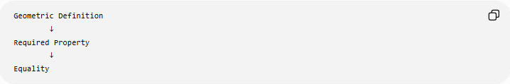
Geometric Definition
↓
Required Property
↓
Equality
For example:
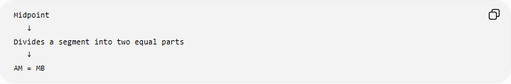
Midpoint
↓
Divides a segment into two equal parts
↓
AM = MB
Or:
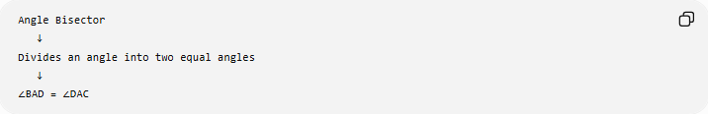
Angle Bisector
↓
Divides an angle into two equal angles
↓
∠BAD = ∠DAC
This makes definitions one of the most direct sources of geometric equality.

Main Types of Equality from Definitions
# Source: AI Source: Provided by: [Data Path: Persons Table -> ID Column: 1, Name_En Column: Motasem Essam] -> From: [ChatGPT] on [7/25/2026]
A practical classification is:
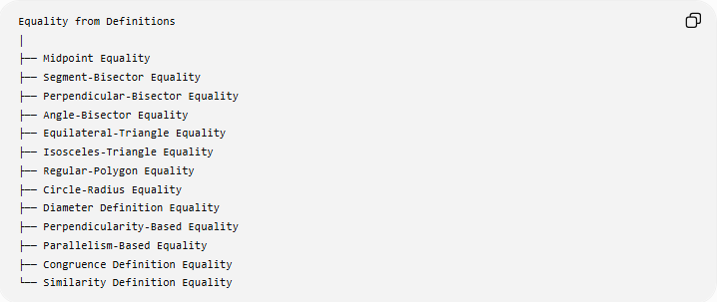
Equality from Definitions
│
├── Midpoint Equality
├── Segment-Bisector Equality
├── Perpendicular-Bisector Equality
├── Angle-Bisector Equality
├── Equilateral-Triangle Equality
├── Isosceles-Triangle Equality
├── Regular-Polygon Equality
├── Circle-Radius Equality
├── Diameter Definition Equality
├── Perpendicularity-Based Equality
├── Parallelism-Based Equality
├── Congruence Definition Equality
└── Similarity Definition Equality
Note: This is a practical classification based on definitions that directly establish equalities. Some of these relationships can also be classified under other sources of equality, such as theorems or properties.

Midpoint Equality
# Source: AI Source: Provided by: [Data Path: Persons Table -> ID Column: 1, Name_En Column: Motasem Essam] -> From: [ChatGPT] on [7/25/2026]
Definition
A midpoint is a point on a line segment that divides the segment into two equal segments.
If $M$is the midpoint of $\overset{‾}{AB}$, then:
$$\boxed{AM=MB}$$
Example
If $M$is the midpoint of $\overset{‾}{AB}$and
$$AB=12\text{ cm},$$
then:
$$AM=MB=6\text{ cm}.$$
The equality comes directly from the definition of midpoint.
Important
The midpoint definition contains two conditions:
- $M$lies on $\overset{‾}{AB}$.
- $AM=MB$.
Therefore:
$$\boxed{M\text{ is midpoint of }AB⇒AM=MB}$$

Segment-Bisector Equality
# Source: AI Source: Provided by: [Data Path: Persons Table -> ID Column: 1, Name_En Column: Motasem Essam] -> From: [ChatGPT] on [7/25/2026]
Definition
A segment bisector is a line, ray, segment, or other geometric object that intersects a segment at its midpoint and therefore divides it into two equal parts.
If line $l$bisects $\overset{‾}{AB}$at $M$:
$$\boxed{AM=MB}$$
Example
If $l$bisects $AB$at $M$, and
$$AM=3x+2, MB=5x-6,$$
then:
$$3x+2=5x-6 \\ 8=2x \\ x=4.$$
Therefore:
$$AM=MB=14.$$
The equality was obtained from the definition of a segment bisector.

Perpendicular-Bisector Equality
# Source: AI Source: Provided by: [Data Path: Persons Table -> ID Column: 1, Name_En Column: Motasem Essam] -> From: [ChatGPT] on [7/25/2026]
Definition
A perpendicular bisector is a line that:
- passes through the midpoint of a segment, and
- is perpendicular to that segment.
If line $l$is the perpendicular bisector of $\overset{‾}{AB}$and intersects it at $M$:
$$\boxed{AM=MB}$$
This equality follows from the bisector part of the definition.
Example
If $M$is the midpoint of $AB$:
$$AM=MB.$$
If:
$$AB=20,$$
then:
$$AM=MB=10.$$
Related distance equality
A point $P$on the perpendicular bisector also satisfies:
$$\boxed{PA=PB}$$
However, this particular result is normally treated as the Perpendicular Bisector Theorem, rather than merely the definition of perpendicular bisector.
That distinction is important.

Angle-Bisector Equality
# Source: AI Source: Provided by: [Data Path: Persons Table -> ID Column: 1, Name_En Column: Motasem Essam] -> From: [ChatGPT] on [7/25/2026]
Definition
An angle bisector divides an angle into two equal angles.
If ray $AD$bisects $∠BAC$:
$$\boxed{m∠BAD=m∠DAC}$$
Example
Suppose:
$$m∠BAC={80}^{∘}.$$
Since $AD$is its angle bisector:
$$m∠BAD=m∠DAC$$
and therefore:
$$m∠BAD=m∠DAC={40}^{∘}.$$
Algebraic Example
If:
$$m∠BAD=3x+5$$
and
$$m∠DAC=5x-15,$$
then:
$$3x+5=5x-15 \\ 20=2x \\ x=10.$$
Thus:
$$m∠BAD=m∠DAC={35}^{∘}.$$

Equilateral-Triangle Equality
# Source: AI Source: Provided by: [Data Path: Persons Table -> ID Column: 1, Name_En Column: Motasem Essam] -> From: [ChatGPT] on [7/25/2026]
Definition
An equilateral triangle is a triangle with three equal side lengths.
Therefore:
$$\boxed{AB=BC=CA}$$
The equality of the three sides follows directly from the definition.
Example
If $△ABC$is equilateral and:
$$AB=8\text{ cm},$$
then:
$$\boxed{AB=BC=CA=8\text{ cm}}$$
Important distinction
The fact that every angle of an equilateral triangle is ${60}^{∘}$is a consequence of its side equality and triangle-angle relationships. The side equality itself is part of the definition.

Isosceles-Triangle Equality
# Source: AI Source: Provided by: [Data Path: Persons Table -> ID Column: 1, Name_En Column: Motasem Essam] -> From: [ChatGPT] on [7/25/2026]
Definition
An isosceles triangle is commonly defined as a triangle with at least two equal sides.
Thus, if $AB=AC$:
$$\boxed{AB=AC}$$
is the defining side equality.
Example
If $△ABC$is isosceles with equal sides $AB$and $AC$, and:
$$AB=10\text{ cm},$$
then:
$$\boxed{AC=10\text{ cm}}$$
Important distinction
The equality
$$AB=AC$$
comes from the definition.
But the equality of the base angles,
$$∠B=∠C,$$
comes from the Isosceles Triangle Theorem, not directly from the definition.

Regular-Polygon Equality
# Source: AI Source: Provided by: [Data Path: Persons Table -> ID Column: 1, Name_En Column: Motasem Essam] -> From: [ChatGPT] on [7/25/2026]
Definition
A regular polygon is a polygon that has:
- all sides equal, and
- all interior angles equal.
Therefore, for a regular $n$-gon:
$$\boxed{s_{1}=s_{2}=s_{3}=⋯=s_{n}}$$
and
$$\boxed{∠_{1}=∠_{2}=⋯=∠_{n}}$$
Example: Regular Hexagon
For a regular hexagon:
$$\boxed{AB=BC=CD=DE=EF=FA}$$
and:
$$\boxed{m∠A=m∠B=m∠C=m∠D=m∠E=m∠F}$$
Since each interior angle is ${120}^{∘}$:
$$m∠A=⋯=m∠F={120}^{∘}.$$
The equal-side and equal-angle properties are part of the definition of a regular polygon.

Circle-Radius Equality
# Source: AI Source: Provided by: [Data Path: Persons Table -> ID Column: 1, Name_En Column: Motasem Essam] -> From: [ChatGPT] on [7/25/2026]
Definition
A circle is the set of all points in a plane that are a fixed distance from a given center.
Therefore, every radius of the same circle has the same length.
If $O$is the center and $A,B,C,D$lie on the circle:
$$\boxed{OA=OB=OC=OD=r}$$
Example
A circle has radius:
$$r=7\text{ cm}.$$
Every radius is therefore:
$$OA=OB=OC=7\text{ cm}.$$
Important distinction
The statement that all radii of a circle are equal follows directly from the fixed-distance definition of a circle.

Diameter Definition Equality
# Source: AI Source: Provided by: [Data Path: Persons Table -> ID Column: 1, Name_En Column: Motasem Essam] -> From: [ChatGPT] on [7/25/2026]
Definition
A diameter is a chord that passes through the center of a circle.
Every diameter of a given circle has length:
$$\boxed{d=2r}$$
Therefore, if $AB$and $CD$are diameters of the same circle:
$$\boxed{AB=CD}$$
Example
If a circle has radius:
$$r=5\text{ cm},$$
then every diameter is:
$$d=2\left(5\right)=10\text{ cm}.$$
Thus:
$$\boxed{AB=CD=10\text{ cm}}$$
for any diameters $AB$and $CD$of that circle.

Perpendicularity-Based Equality
# Source: AI Source: Provided by: [Data Path: Persons Table -> ID Column: 1, Name_En Column: Motasem Essam] -> From: [ChatGPT] on [7/25/2026]
Perpendicularity itself does not generally define two lengths as equal.
However, certain definitions involving perpendicularity do produce equality.
For example, a perpendicular bisector combines:
$$\text{perpendicularity}+\text{bisection}.$$
The bisection gives:
$$\boxed{AM=MB}$$
So it is important not to incorrectly conclude:
$$l_{1}⊥l_{2}⇒\text{some lengths are equal}.$$
That is not generally true.
Example
Two perpendicular lines can have completely different segment lengths:
$$AB=3, CD=10.$$
Perpendicularity alone does not imply:
$$AB=CD.$$

Parallelism-Based Equality
# Source: AI Source: Provided by: [Data Path: Persons Table -> ID Column: 1, Name_En Column: Motasem Essam] -> From: [ChatGPT] on [7/25/2026]
Parallelism alone also does not generally define equality of lengths.
For example:
$$l_{1}∥l_{2}$$
does not imply that arbitrary segments on those lines are equal.
However, some definitions involving parallel lines can create equal geometric quantities.
For example, a parallelogram is defined by having two pairs of opposite sides parallel:
$$AB∥CD, AD∥BC.$$
The opposite-side equalities
$$AB=CD, AD=BC$$
are properties/theorems of parallelograms, rather than direct consequences of the parallelism definition alone.
This distinction is important when classifying Equality from Definitions.

Congruence Definition Equality
# Source: AI Source: Provided by: [Data Path: Persons Table -> ID Column: 1, Name_En Column: Motasem Essam] -> From: [ChatGPT] on [7/25/2026]
Definition
Two geometric figures are congruent if they have the same shape and size and their corresponding parts match.
Therefore, corresponding measurements of congruent figures are equal.
For example:
$$△ABC≅△DEF$$
gives:
$$AB=DE \\ BC=EF \\ AC=DF$$
and:
$$m∠A=m∠D$$
etc.
Important classification
In a proof, these equalities are usually described as:
$$\boxed{\text{Equality from Congruence}}$$
rather than simply Equality from Definitions.
Congruence itself has a definition, but the practical proof step is normally classified under the separate category Equality from Congruence.

Similarity Definition Equality
# Source: AI Source: Provided by: [Data Path: Persons Table -> ID Column: 1, Name_En Column: Motasem Essam] -> From: [ChatGPT] on [7/25/2026]
Similarity directly establishes:
$$\boxed{\text{Corresponding angles are equal}}$$
and:
$$\boxed{\text{Corresponding lengths are proportional}}$$
For example:
$$△ABC∼△DEF$$
gives:
$$\boxed{∠A=∠D}$$
but generally:
$$AB≠DE.$$
Instead:
$$\frac{AB}{DE}=\frac{BC}{EF}=\frac{AC}{DF}.$$
Therefore, similarity primarily gives angle equality and ratio equality, not general length equality.
If the scale factor is:
$$k=1,$$
then corresponding lengths become equal.

Summary Table
# Source: AI Source: Provided by: [Data Path: Persons Table -> ID Column: 1, Name_En Column: Motasem Essam] -> From: [ChatGPT] on [7/25/2026]
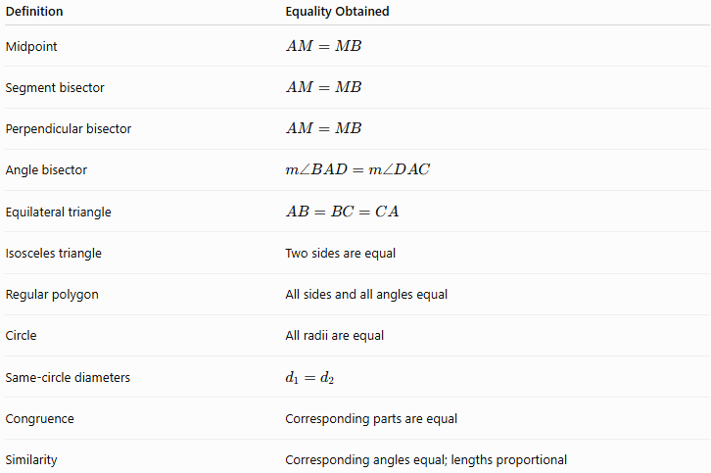
Definition | Equality Obtained
Midpoint | $$AM=MB$$
Segment bisector | $$AM=MB$$
Perpendicular bisector | $$AM=MB$$
Angle bisector | $$m∠BAD=m∠DAC$$
Equilateral triangle | $$AB=BC=CA$$
Isosceles triangle | Two sides are equal
Regular polygon | All sides and all angles equal
Circle | All radii are equal
Same-circle diameters | $$d_{1}=d_{2}$$
Congruence | Corresponding parts are equal
Similarity | Corresponding angles equal; lengths proportional

Definition Equality vs Theorem Equality
# Source: AI Source: Provided by: [Data Path: Persons Table -> ID Column: 1, Name_En Column: Motasem Essam] -> From: [ChatGPT] on [7/25/2026]
This distinction is especially important.
Equality directly contained in a definition
$$\boxed{\text{Definition}→\text{Equality}}$$
Examples:
$$M\text{ midpoint}⇒AM=MB \\ AD\text{ angle bisector}⇒∠BAD=∠DAC \\ △ABC\text{ equilateral}⇒AB=BC=CA$$
Equality derived by a theorem
$$\boxed{\text{Definition/Givens}→\text{Theorem}→\text{Equality}}$$
Example:
$$AB=AC$$
in an isosceles triangle leads by the Isosceles Triangle Theorem to:
$$∠B=∠C.$$
The angle equality is not the definition; it is a theorem.

Equality from Definitions in Proofs
# Source: AI Source: Provided by: [Data Path: Persons Table -> ID Column: 1, Name_En Column: Motasem Essam] -> From: [ChatGPT] on [7/25/2026]
Definitions are frequently used as the first logical step in geometric proofs.
Example
Given: $M$is the midpoint of $\overset{‾}{AB}$.
Prove: $AM=MB$.
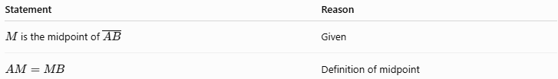
Statement | Reason
$M$is the midpoint of $\overset{‾}{AB}$ | Given
$$AM=MB$$ | Definition of midpoint
Therefore:
$$\boxed{AM=MB}$$
This is one of the simplest possible geometric proofs.

Another Example: Angle Bisector
# Source: AI Source: Provided by: [Data Path: Persons Table -> ID Column: 1, Name_En Column: Motasem Essam] -> From: [ChatGPT] on [7/25/2026]
Given: $AD$bisects $∠BAC$.
Prove:
$$m∠BAD=m∠DAC.$$
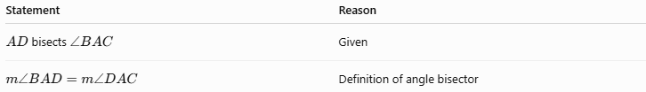
Statement | Reason
$AD$bisects $∠BAC$ | Given
$$m∠BAD=m∠DAC$$ | Definition of angle bisector
Thus:
$$\boxed{m∠BAD=m∠DAC}$$

Classification Summary
# Source: AI Source: Provided by: [Data Path: Persons Table -> ID Column: 1, Name_En Column: Motasem Essam] -> From: [ChatGPT] on [7/25/2026]
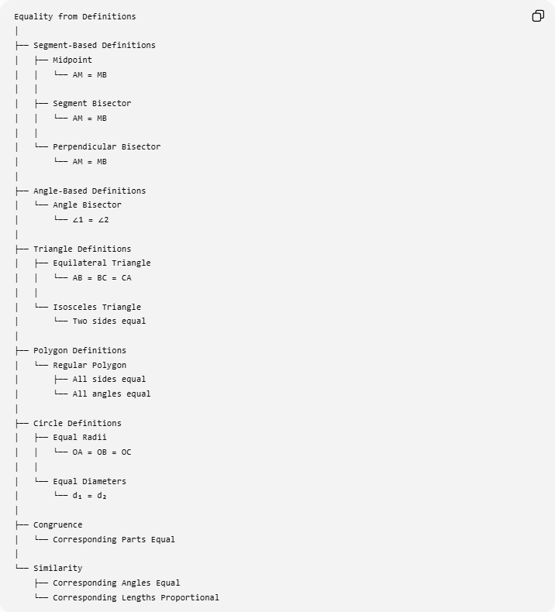
Equality from Definitions
│
├── Segment-Based Definitions
│ ├── Midpoint
│ │ └── AM = MB
│ │
│ ├── Segment Bisector
│ │ └── AM = MB
│ │
│ └── Perpendicular Bisector
│ └── AM = MB
│
├── Angle-Based Definitions
│ └── Angle Bisector
│ └── ∠1 = ∠2
│
├── Triangle Definitions
│ ├── Equilateral Triangle
│ │ └── AB = BC = CA
│ │
│ └── Isosceles Triangle
│ └── Two sides equal
│
├── Polygon Definitions
│ └── Regular Polygon
│ ├── All sides equal
│ └── All angles equal
│
├── Circle Definitions
│ ├── Equal Radii
│ │ └── OA = OB = OC
│ │
│ └── Equal Diameters
│ └── d₁ = d₂
│
├── Congruence
│ └── Corresponding Parts Equal
│
└── Similarity
├── Corresponding Angles Equal
└── Corresponding Lengths Proportional

Relationship to Other Types of Geometric Equality
# Source: AI Source: Provided by: [Data Path: Persons Table -> ID Column: 1, Name_En Column: Motasem Essam] -> From: [ChatGPT] on [7/25/2026]
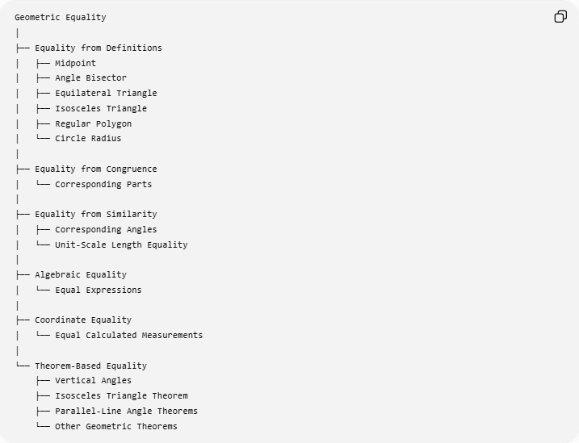
Geometric Equality
│
├── Equality from Definitions
│ ├── Midpoint
│ ├── Angle Bisector
│ ├── Equilateral Triangle
│ ├── Isosceles Triangle
│ ├── Regular Polygon
│ └── Circle Radius
│
├── Equality from Congruence
│ └── Corresponding Parts
│
├── Equality from Similarity
│ ├── Corresponding Angles
│ └── Unit-Scale Length Equality
│
├── Algebraic Equality
│ └── Equal Expressions
│
├── Coordinate Equality
│ └── Equal Calculated Measurements
│
└── Theorem-Based Equality
├── Vertical Angles
├── Isosceles Triangle Theorem
├── Parallel-Line Angle Theorems
└── Other Geometric Theorems

Key Points
# Source: AI Source: Provided by: [Data Path: Persons Table -> ID Column: 1, Name_En Column: Motasem Essam] -> From: [ChatGPT] on [7/25/2026]
- Equality from Definitions obtains equality directly from what a geometric term means.
- A midpoint gives:
$$\boxed{AM=MB}$$
- An angle bisector gives:
$$\boxed{∠1=∠2}$$
- An equilateral triangle gives:
$$\boxed{AB=BC=CA}$$
- An isosceles triangle has two equal sides by its definition.
- A regular polygon has equal sides and equal angles by definition.
- All radii of one circle are equal.
- All diameters of one circle are equal.
- Perpendicularity alone does not imply equality.
- Parallelism alone does not imply equality.
- Some equalities associated with a definition are actually consequences of theorems, so the logical source should be identified accurately.
- Definitions are especially important in the first steps of geometric proofs.

Conclusion
# Source: AI Source: Provided by: [Data Path: Persons Table -> ID Column: 1, Name_En Column: Motasem Essam] -> From: [ChatGPT] on [7/25/2026]
$$\boxed{\text{Equality from Definitions}=\text{Equality obtained directly from the meaning of a geometric definition}}$$
The most fundamental examples are:
$$\boxed{M\text{ midpoint}⇒AM=MB} \\ \boxed{\text{Angle bisector}⇒∠1=∠2} \\ \boxed{\text{Equilateral triangle}⇒AB=BC=CA} \\ \boxed{\text{Regular polygon}⇒\text{all sides and angles equal}} \\ \boxed{\text{Circle}⇒OA=OB=OC=⋯=r}$$
Thus, definitions provide some of the most direct and fundamental sources of geometric equality, while theorems, congruence, similarity, algebra, and coordinate methods provide additional ways to establish equalities.

